The Great Pacific Garbage Patch
Name
Institution
Course
Date

The Great Pacific Garbage Patch
Introduction
Synthetic and plastic remains in the oceans cause very negative effects on marine plants, animals and the entire hydrosphere in general. The ocean waste has catastrophic effect on both the quality and quantity of the resources offered by oceans. A good example of the effects of ocean waste is the Great Pacific Garbage Patch (GPGP), the largest landfill in the world, which is located in the central Pacific Ocean. Over time, a number of international treaties and agreements have been entered targeting the causes of GPGP. However, despite the numerous agreements and treaties, the world nations seem to have ignored the major cause of GPGP (Harse, 2011). According to research, the course of GPGP can be reversed if every nation would focus on strengthening the quality of their domestic water and enhancing waste disposal.
When domestic water is released to national waterways with plastic debris and other contaminations, the debris are ultimately delivered to the oceans and hence causing disastrous effects (Harse, 2011). This project will aim at answering some key questions which will serve as the objectives of the project. The first focus will be on the cause of GPGP. The second objective of the project will be the effects of GPGP to the hydrosphere in general and lastly, the project will focus on the preventive measures to resolve or prevent the situation from worsening.
Background
The GPGP is basically an area concentrated with marine debris in the North Pacific Ocean. It is located between Hawaii and Californian and off the coast of Japan. In these areas, there are currents which descend from the surrounding mountains and contribute a lot in converging waste. For many years, the areas have served as the garbage disposal for the Pacific. the wastes that collect at the GPGP do not readily biodegrade and are causing much effect to the hydrosphere. Plastic debris in the oceans and seas lead to the introduction of strange species which can prove to be aggressive.
Data
According to britannica.com, the major cause of the GPGP is the waste that is carried by currents in the North Pacific. The current takes a clockwise rotation and hence, draws solid waste such as plastics. Britannica.com reveals that 80 percent of the waste is plastic which forms the patch because it is not readily biodegradable like many other wastes (Bauer, 2019). On the other hand, according to nature.com, an internet source that offers data concerning the accumulation of plastic in the patch, thousands of tons of ocean plastic are floating in the GPGP (Lebreton, et al, 2018). in addition, nature.com reveals that more than 75 percent of the debris in the GPGP are larger than 5 centimeters and majority of them are pieces of fishing nets.
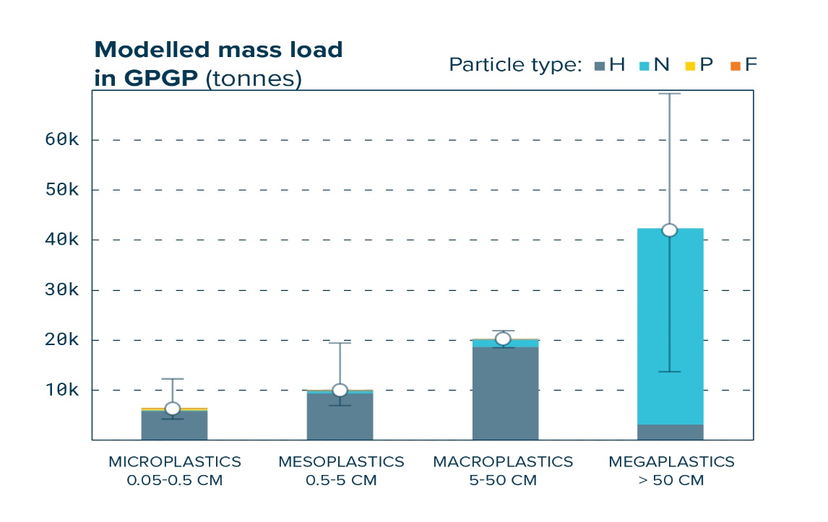
Both Britannica.com and nature.com are reliable sources because they draw their data from national geographic and specifically the physical geography of water. To get the sources, I searched over the internet specifically on the key causes of GPGP (Bauer, 2019). To prepare the data for analysis, I had to compare it with data from other sources. However, considering where the sources drew their data and its explicit explanation on marine environment, I considered it relevant to my topic.
As revealed by bbcleaningservice.com, an American agency concerned with ensuring a clean marine environment, while 80 percent of the trash in the GPGP is plastic, the other 20 percent comprise of waste from fishing boats and ships on the ocean. According to experts, plastic makes the larger percentage because it does not decompose and hence floats in the water and keeps moving along with currents until they get to the patch.
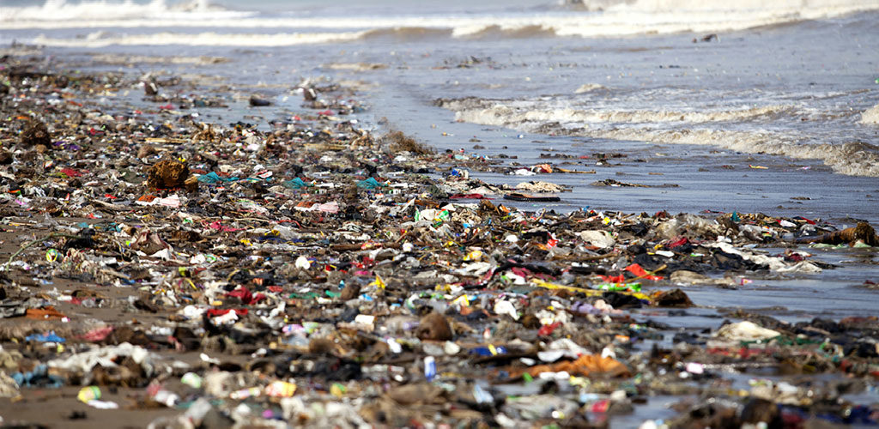
Plastic pollution in the hydrosphere
bbcleaningservice.com explains that the pollution has caused a lot of harm in the marine environment. Apart from many marine wildlife losing lives after feeding on the trash, others are entangled and trapped in the trash until they die. In addition, the presence of the plastic garbage patch hinders even plant growth. This is because the patch has formed a cover over the waters and sunlight cannot penetrate and hence, sea plants are not growing as they should (Wiszniewski, 2018). With minimal plant growth in the ocean, the overall food chain is suppressed, causing a negative effect to the entire hydrosphere.
There are however measures to minimize any further growth of the patch. Researchers from bbcleaningservice.com and those from the journal of environmental law have both indicated that due to the size and extensive nature of the GPGP, cleaning is quite impractical. According to bbcleaningservice.com, the menace can be controlled by preventing addition of more plastic trash in the garbage patches. According the journal of environmental law, because most of the marine debris come from the coastal land, countries and states should come up with measures to prevent them from getting into the ocean. The states around the ocean should come up with laws to control land-based sources from getting into the ocean (Riddle, 2019).
Results
It is evident from the data analyzed that the GPGP occupies a very large are of the ocean. As revealed in brittanica.com, the estimated are occupied by the GPGP is an equivalent of Texas or Alaska states. From the data, it has also come out clear that more than 75 percent of the trash in the patches are mega plastics. Plastic bottles and pieces of fishing nets comprise of the greater percentage of the garbage according to the data analyzed. Additionally, the trash has had numerous negative effects on the hydrosphere and it is evident from the data that preventive measures should be taken to control the pollution (Riddle, 2019).

Conclusion
Plastic debris in the oceans and particularly the North Pacific Ocean has had numerous effects on both animals and marine plants. The GPGP has mainly been built up by trash that originate from the coastal land into the ocean and accumulate to the patch. Most of the trash in the GPGP is mega plastic comprising of pieces of fishing nets and other plastic materials. To control expansion if the patch, critical measures need to be taken. Although there are regulations currently in place which protect the United States waters and landfills, they have proven to be inadequate and further strict measure and regulations would help minimize the rate of waste that gets into the ocean.

References
Bauer, P. (2019). Great Pacific Garbage Patch. Polluted region, Pacific Ocean. Retrieved from: https://www.britannica.com/topic/Great-Pacific-Garbage-Patch
Harse, G. A. (2011). Plastic, the great pacific garbage patch, and international misfires at a cure. UCLA J. Envtl. L. & Pol'y, 29, 331.
Lebreton, L., Slat, B., Ferrari, F., Sainte-Rose, B., Aitken, J., Marthouse, R., ... & Noble, K. (2018). Evidence that the Great Pacific Garbage Patch is rapidly accumulating plastic. Scientific reports, 8(1), 1-15. retrieved from: https://www.nature.com/articles/s41598-018-22939-w
Riddle, B. (2019). Monitoring the hydrosphere. Science Scope, 42(5), 18.
Wiszniewski, G. (2018). Clean Our Oceans: The Impact of the Great Pacific Garbage Patch. Retrieved from: https://www.bbcleaningservice.com/great-pacific-garbage-patch.html

